Java Package

A **java package** is a group of similar types of classes, interfaces and sub-packages.

Package in java can be categorized in two form, built-in package and user-defined package.There are many built-in packages such as java, lang, awt, javax, swing, net, io, util, sql etc.Here, we will have the detailed learning of creating and using user-defined packages.

**Advantage of Java Package**

1) Java package is used to categorize the classes and interfaces so that they can be easily maintained.

2) Java package provides access protection.

3) Java package removes naming collision.

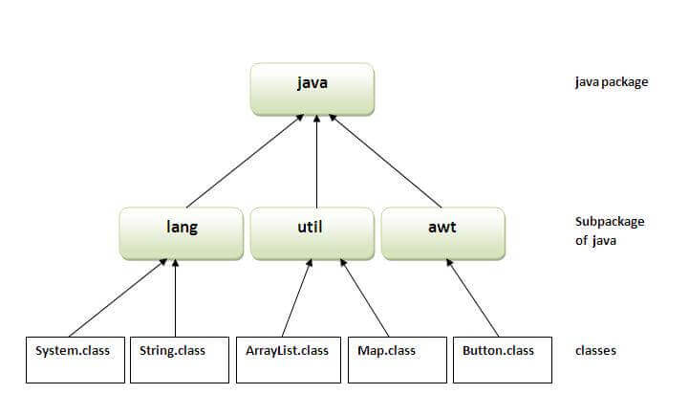

**Simple example of java package**

The package keyword is used to create a package in java.

//save as Simple.java

package mypack;

public class Simple

{

public static void main(String args[])

{

System.out.println("Welcome to package");

}

}

**How to compile java package**

|  |
| --- |
| **To Compile:** javac -d . Simple.java |
| **To Run:** java mypack.Simple |

**How to access package from another package?**

There are two ways to access the package from outside the package.

* import package.*;
* import package.classname;

**1) Using packagename.\***

If you use package.* then all the classes and interfaces of this package will be accessible but not subpackages.

The import keyword is used to make the classes and interface of another package accessible to the current package.

**Example of package that import the packagename.\***

//save by A.java

package pack;

public class A

{

public void msg()

{

System.out.println("Hello");

}

}

//save by B.java

package mypack;

import pack.*;

class B

{

public static void main(String args[])

{

A obj = new A();

obj.msg();

}

}

**2) Using packagename.classname**

If you import package.classname then only declared class of this package will be accessible.

**Example of package by import package.classname**

//save by A.java

package pack;

public class A

{

public void msg(){System.out.println("Hello");}

}

//save by B.java

package mypack;

import pack.A;

class B

{

public static void main(String args[])

{

A obj = new A();

obj.msg();

}

}